**Week 3: Spring core and Maven**

**Exercise 1: Configuring a Basic Spring Application**

**Pom.xml (LibraryManagement)**

<project xmlns="http://maven.apache.org/POM/4.0.0"

xmlns:xsi="http://www.w3.org/2001/XMLSchema-instance"

xsi:schemaLocation="http://maven.apache.org/POM/4.0.0

http://maven.apache.org/xsd/maven-4.0.0.xsd">

<modelVersion>4.0.0</modelVersion>

<groupId>com.library</groupId>

<artifactId>LibraryManagement</artifactId>

<version>1.0-SNAPSHOT</version>

<dependencies>

<!-- Spring Core -->

<dependency>

<groupId>org.springframework</groupId>

<artifactId>spring-context</artifactId>

<version>5.3.32</version>

</dependency>

</dependencies>

</project>

**MainApp.java**

package com.library;

import org.springframework.context.ApplicationContext;

import org.springframework.context.support.ClassPathXmlApplicationContext;

import com.library.service.BookService;

public class MainApp {

public static void main(String[] args) {

ApplicationContext context = new ClassPathXmlApplicationContext("applicationContext.xml");

BookService bookService = (BookService) context.getBean("bookService");

bookService.displayBook();

    }

}

**BookService.java**

package com.library.service;

import com.library.repository.BookRepository;

public class BookService {

private BookRepository bookRepository;

public void setBookRepository(BookRepository bookRepository) {

this.bookRepository = bookRepository;

}

public void displayBook() {

System.out.println("📚 BookService: Preparing to display book...");

bookRepository.fetchBook();

    }

}

**BookRepository.java**

package com.library.repository;

public class BookRepository {

public void fetchBook() {

System.out.println("📘 BookRepository: Fetching book from database...");

    }

}

**applicationContext.xml**  
  
<?xml version="1.0" encoding="UTF-8"?>

<beans xmlns="http://www.springframework.org/schema/beans"

xmlns:xsi="http://www.w3.org/2001/XMLSchema-instance"

xsi:schemaLocation="

http://www.springframework.org/schema/beans

http://www.springframework.org/schema/beans/spring-beans.xsd">

<bean id="bookRepository" class="com.library.repository.BookRepository" />

<bean id="bookService" class="com.library.service.BookService">

<property name="bookRepository" ref="bookRepository"/>

</bean>

</beans>

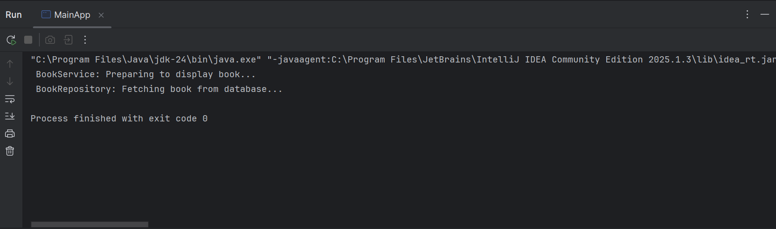  
  
**Exercise 2: Implementing Dependency injection:**

**MainApp.java**

package com.library;

import org.springframework.context.ApplicationContext;

import org.springframework.context.support.ClassPathXmlApplicationContext;

import com.library.service.BookService;

public class MainApp {

public static void main(String[] args) {

ApplicationContext context = new ClassPathXmlApplicationContext("applicationContext.xml");

BookService bookService = (BookService) context.getBean("bookService");

bookService.displayBook();

}

}

**BookRepository.java**

package com.library.repository;

public class BookRepository {

public void fetchBook() {

System.out.println("BookRepository: Fetching book from the database...");

}

}

**BookService.java**

package com.library.service;

import com.library.repository.BookRepository;

public class BookService {

private BookRepository bookRepository;

public void setBookRepository(BookRepository bookRepository) {

this.bookRepository = bookRepository;

}

public void displayBook() {

System.out.println("BookService: Preparing to display book...");

bookRepository.fetchBook();

}

}

**applicationContext.xml**

<?xml version="1.0" encoding="UTF-8"?>

<beans xmlns="http://www.springframework.org/schema/beans"

xmlns:xsi="http://www.w3.org/2001/XMLSchema-instance"

xsi:schemaLocation="

http://www.springframework.org/schema/beans

http://www.springframework.org/schema/beans/spring-beans.xsd">

<bean id="bookRepository" class="com.library.repository.BookRepository" />

<bean id="bookService" class="com.library.service.BookService">

<property name="bookRepository" ref="bookRepository"/>

</bean>

</beans>

**Pom.xml**

<project xmlns="http://maven.apache.org/POM/4.0.0"

xmlns:xsi="http://www.w3.org/2001/XMLSchema-instance"

xsi:schemaLocation="http://maven.apache.org/POM/4.0.0

http://maven.apache.org/xsd/maven-4.0.0.xsd">

<modelVersion>4.0.0</modelVersion>

<groupId>com.library</groupId>

<artifactId>LibraryManagement</artifactId>

<version>1.0-SNAPSHOT</version>

<dependencies>

<!-- Spring Core -->

<dependency>

<groupId>org.springframework</groupId>

<artifactId>spring-context</artifactId>

<version>5.3.32</version>

</dependency>

</dependencies>

</project>



**Exercise 4: Creating and Configuring a Maven Project**

**MainApp.java**

package com.library;

public class MainApp {

public static void main(String[] args) {

System.out.println(" - Project Setup Successful!");

}

}

**Pom.xml**

<project xmlns="http://maven.apache.org/POM/4.0.0"

xmlns:xsi="http://www.w3.org/2001/XMLSchema-instance"

xsi:schemaLocation="http://maven.apache.org/POM/4.0.0

http://maven.apache.org/xsd/maven-4.0.0.xsd">

<modelVersion>4.0.0</modelVersion>

<groupId>com.library</groupId>

<artifactId>LibraryManagement</artifactId>

<version>1.0-SNAPSHOT</version>

<dependencies>

<!-- Spring Context -->

<dependency>

<groupId>org.springframework</groupId>

<artifactId>spring-context</artifactId>

<version>5.3.32</version>

</dependency>

<!-- Spring AOP -->

<dependency>

<groupId>org.springframework</groupId>

<artifactId>spring-aop</artifactId>

<version>5.3.32</version>

</dependency>

<!-- Spring Web MVC -->

<dependency>

<groupId>org.springframework</groupId>

<artifactId>spring-webmvc</artifactId>

<version>5.3.32</version>

</dependency>

</dependencies>

<build>

<plugins>

<plugin>

<groupId>org.apache.maven.plugins</groupId>

<artifactId>maven-compiler-plugin</artifactId>

<version>3.8.1</version>

<configuration>

<source>1.8</source>

<target>1.8</target>

</configuration>

</plugin>

</plugins>

</build>

</project>s

